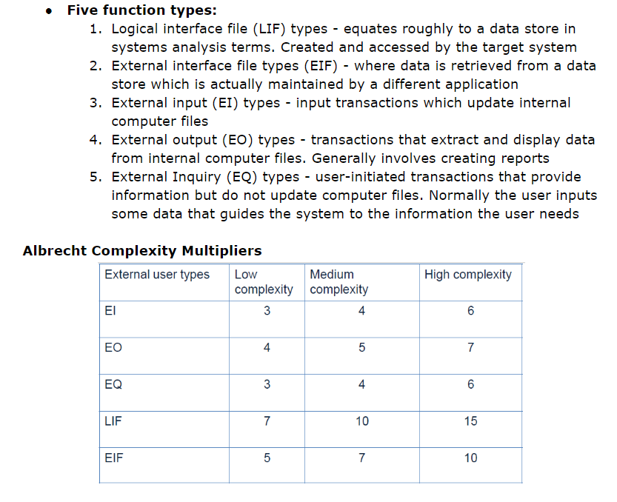

List of Function Points:

Preconditions:

* A set of images is retrieved and stored in the server database (LIF - Low)

Sign-Up Feature

* Set of pictures are made available to the user (EIF - Low)
* The user selects an arbitrary number of images in a specific order (EQ - Medium)
* User is asked to repeat this selection twice more to confirm the password order (EQ - Medium)
* Store user login information (username/email & picture selection) (EI - Medium)
* Store picture set information (EI - Low)

Login Feature

* Take username/email and reference it against database (EQ - Low)
* Display Set of images (EO - Low)
* The user selects images in order (EQ - Low)
* Order of images is referenced against the database (EQ - Low)

Password Encryption/Security

* Consecutive picture IDs for each password are hashed and stored (EI - Med)
* Hashing is done server-side, the client only sends selected pictures to the server (EI - Med)

|  |  |  |  |  |
| --- | --- | --- | --- | --- |
| Category | Low | Medium | High | Total |
| EO | 1x4 | 0 | 0 | 4 |
| EQ | 3x3 | 2x4 | 0 | 17 |
| EI | 1x3 | 2x4 | 0 | 11 |
| EIF | 1x5 | 0 | 0 | 5 |
| LIF | 1x7 | 0 | 0 | 7 |
| Total Function Points: 44 | | | | |

Data Communications: 4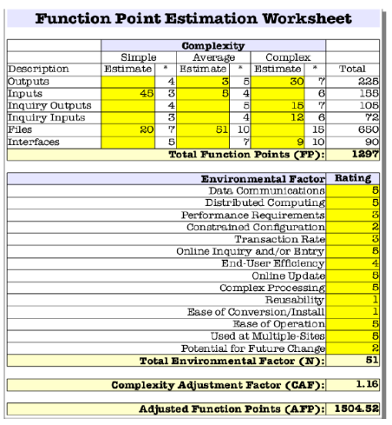

Distributed Computing: 1

Performance Requirements: 2

Constrained Configuration: 1

Transaction Rate: 3

Online Inquiry and/or Entry: 4

End User Efficiency: 3

Offline Update: 1

Complex Processing: 2

Reusability: 3

Ease of Conversion/Install: 2

Ease of operation: 2

Used at multiple sites: 1

Potential for future change: 1

**Total Environmental Factor**: 30

**Complexity Adjustment Factor:** 0.95

**Adjusted Function Points:** 41.8

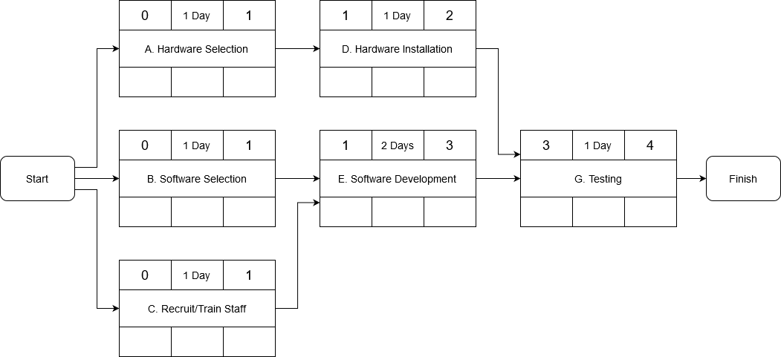

**Risks**

|  |  |
| --- | --- |
| **Risks** | **Countermeasures** |
| Unrealistic time estimates | * Schedule tasks in such a way that two tasks can be tackled at the same time. * Do not rush tasks, quality is of utmost importance. * Leave cushion time in case of unexpected issues/ change of requirements. |
| A last-minute change in requirements | * Leave some cushion room while scheduling task times such that there is time left over for any additional requirements. * Work in a more incremental development model. |
| Gold plating | * Focus on the requirements and do what is asked in the requirements. * Do not try to get “fancy” with everything, make the program usable. * Focus on the functionality of the program and usable user interfaces. |